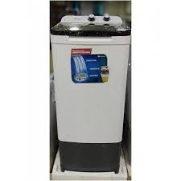

DS-9000CM

* Smart Slim Shape
* Rinse Option
* Black Top Lid
* White Color

• **Rs.83,000**